**Container as a Service (Docker)**

**Suresh durairajan chief arch**

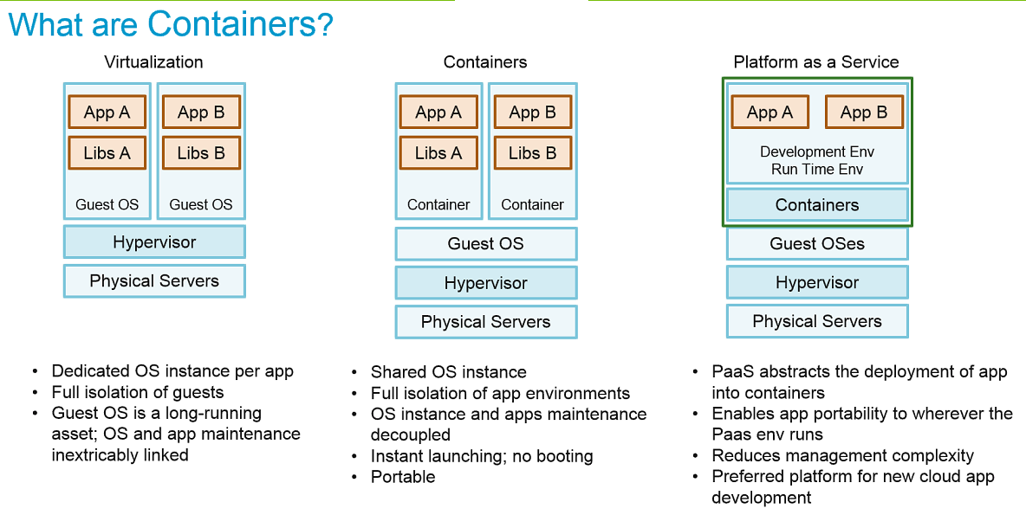

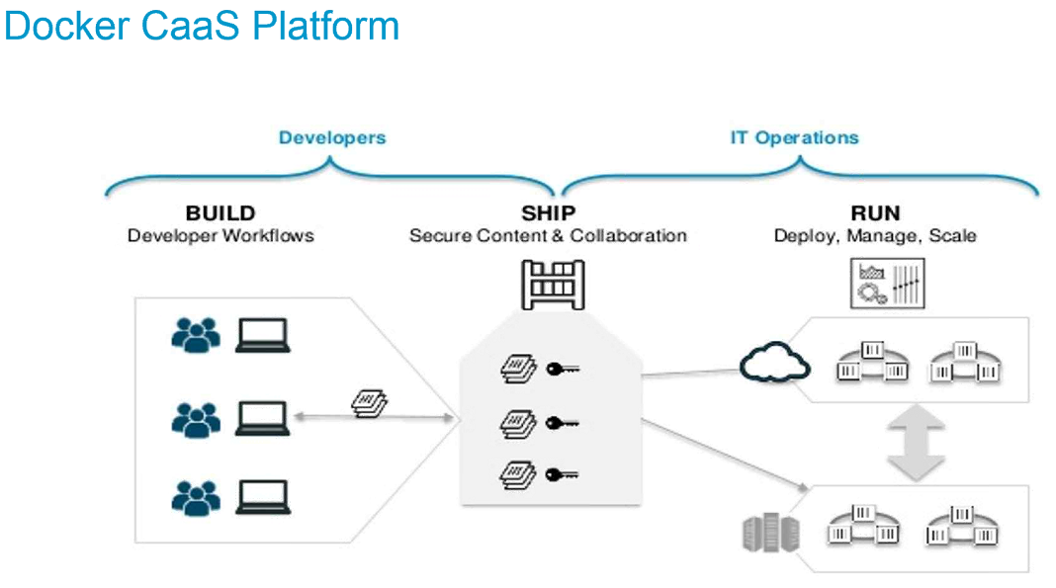

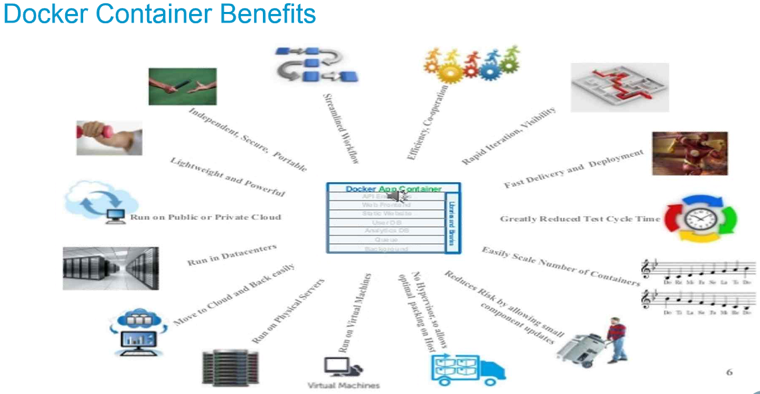

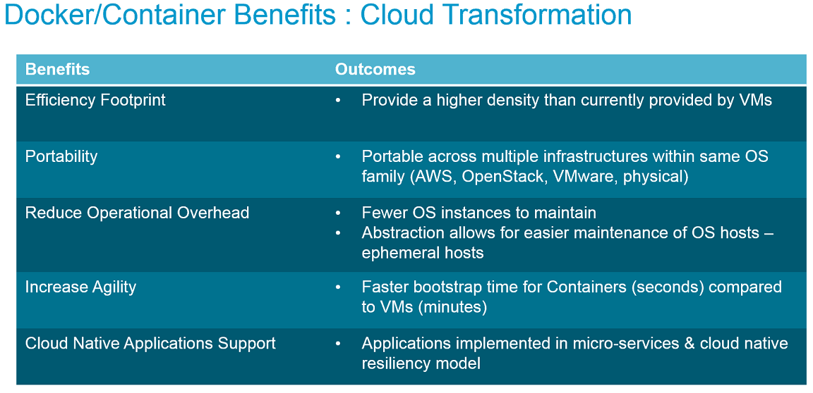

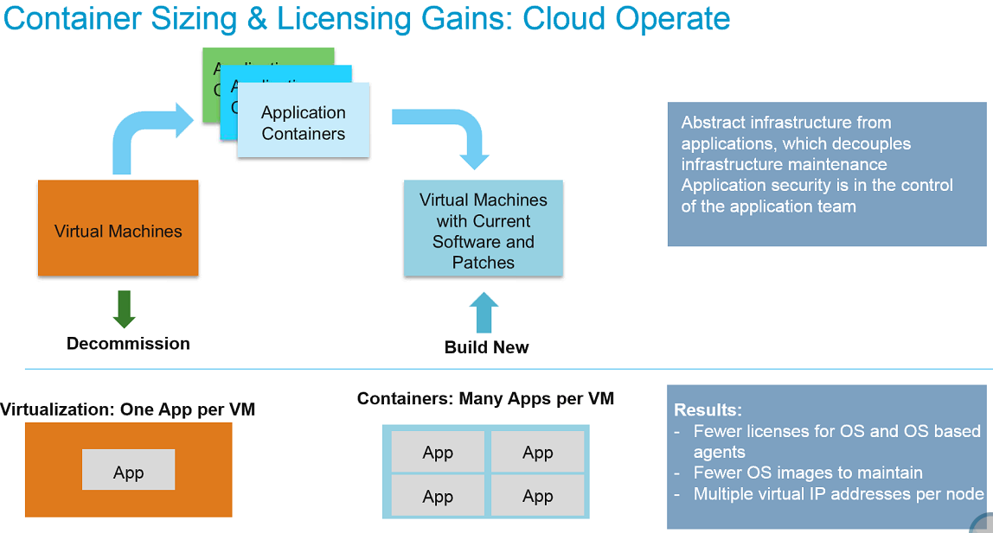

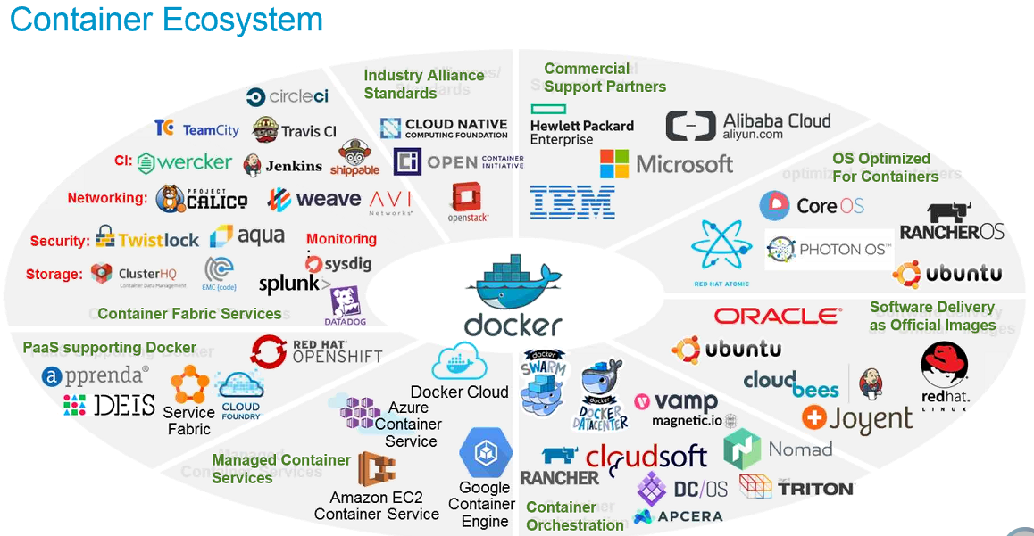

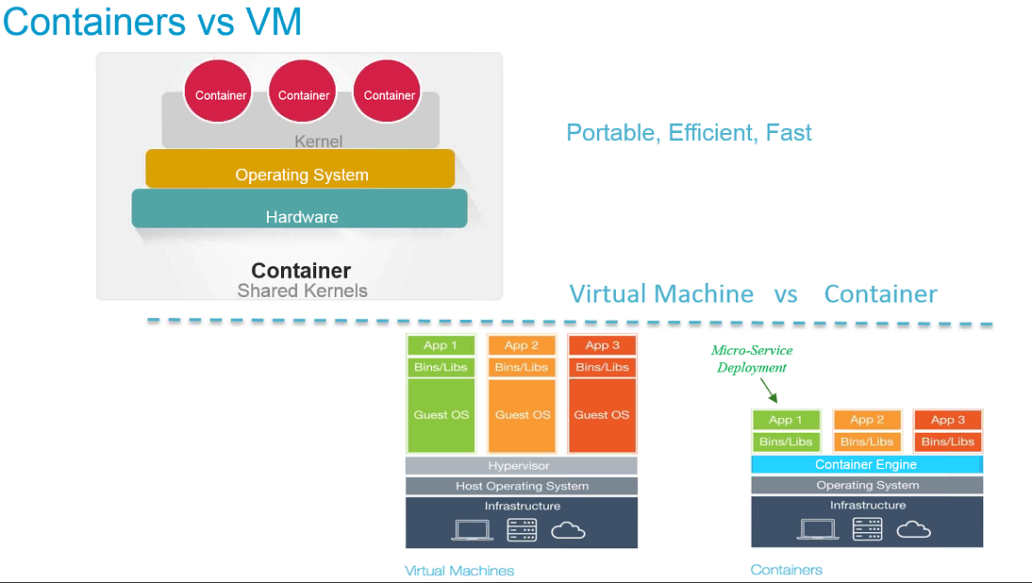

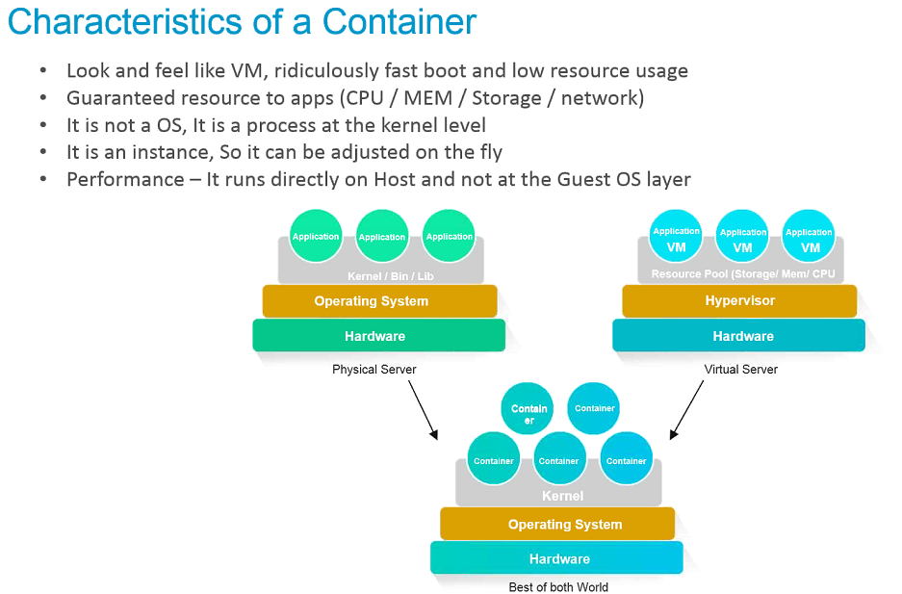

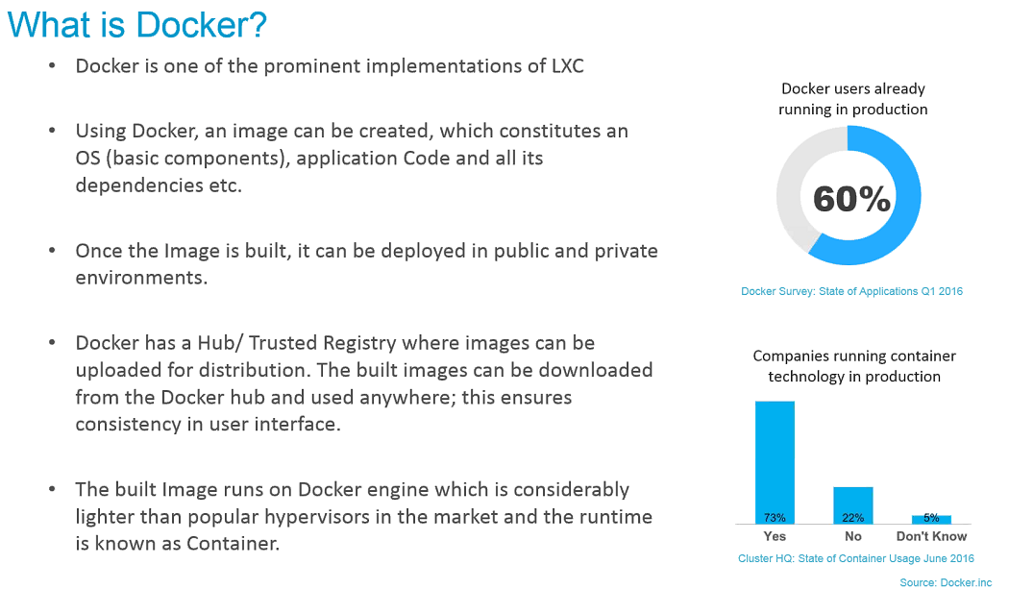

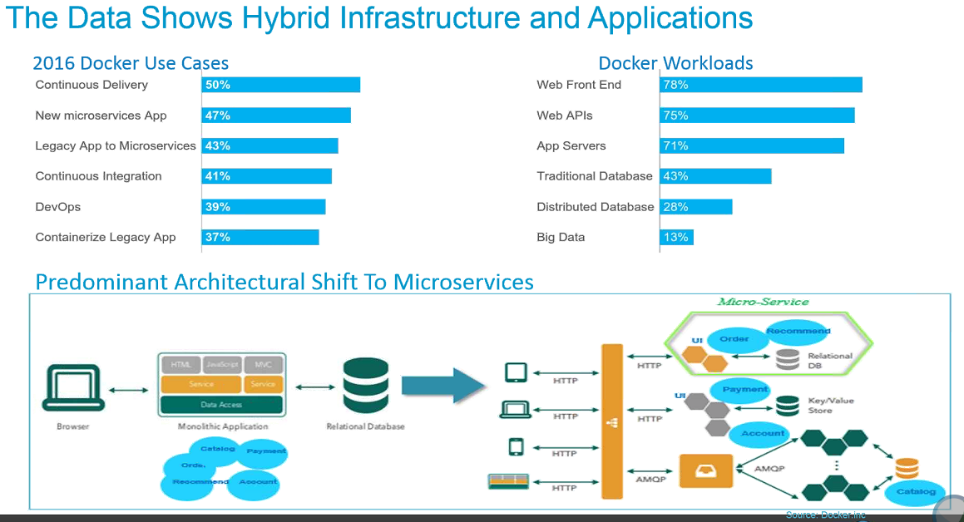

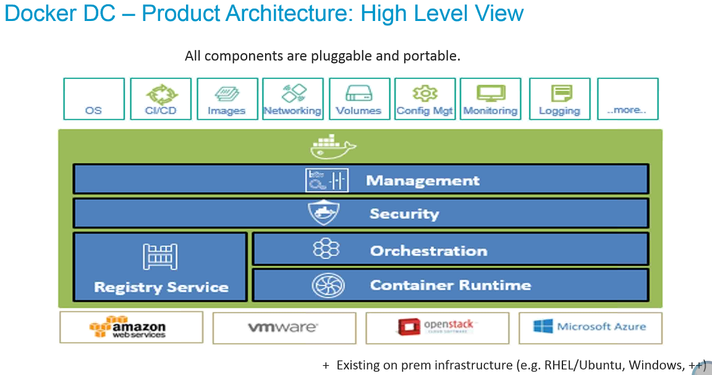

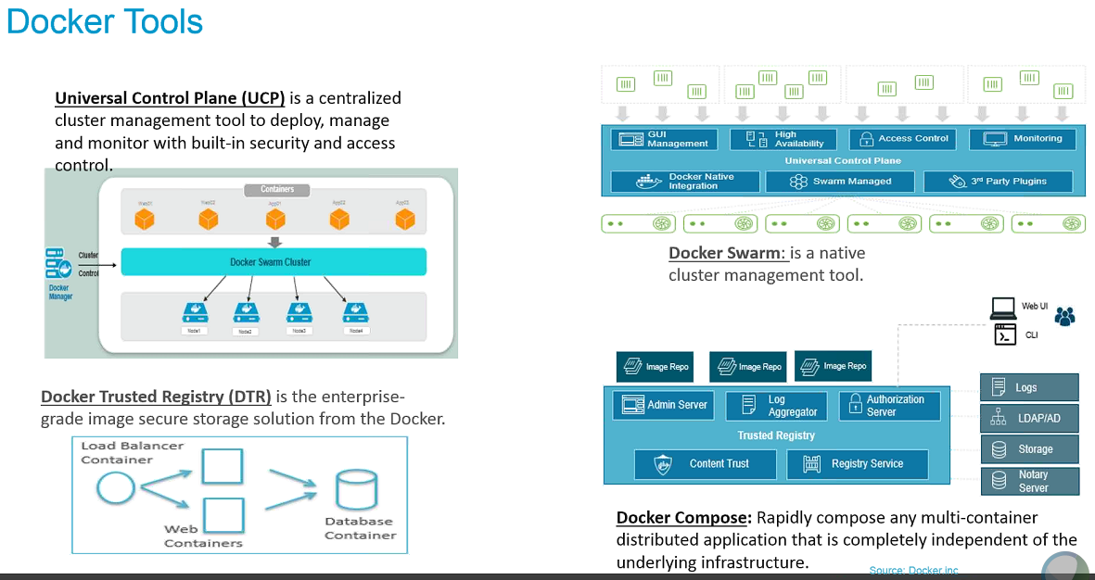

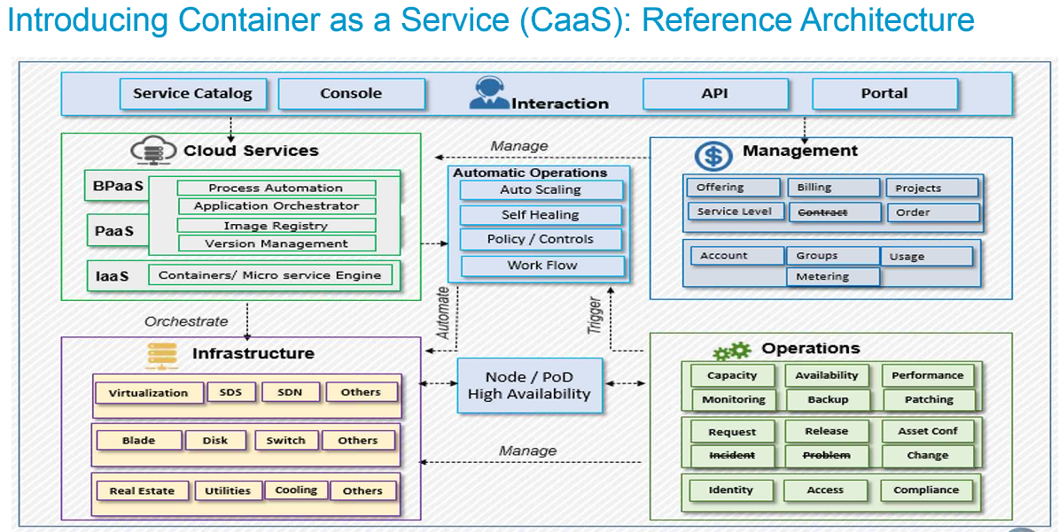

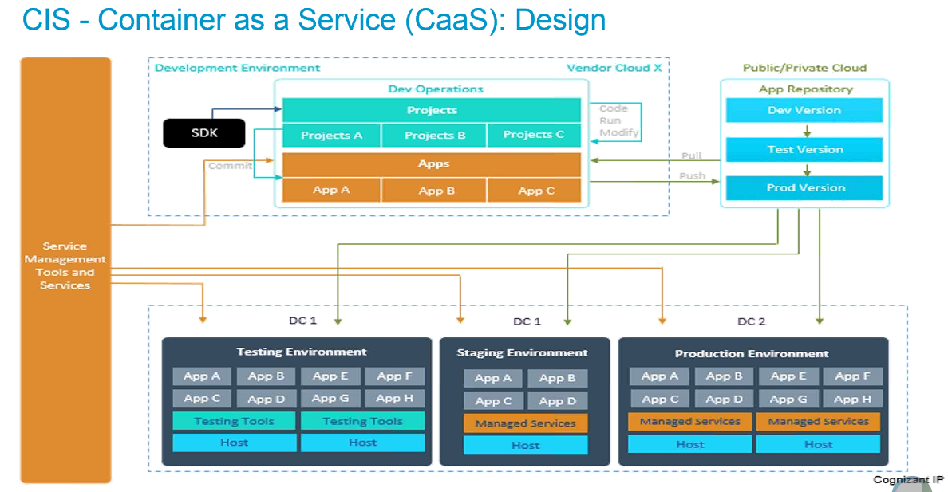

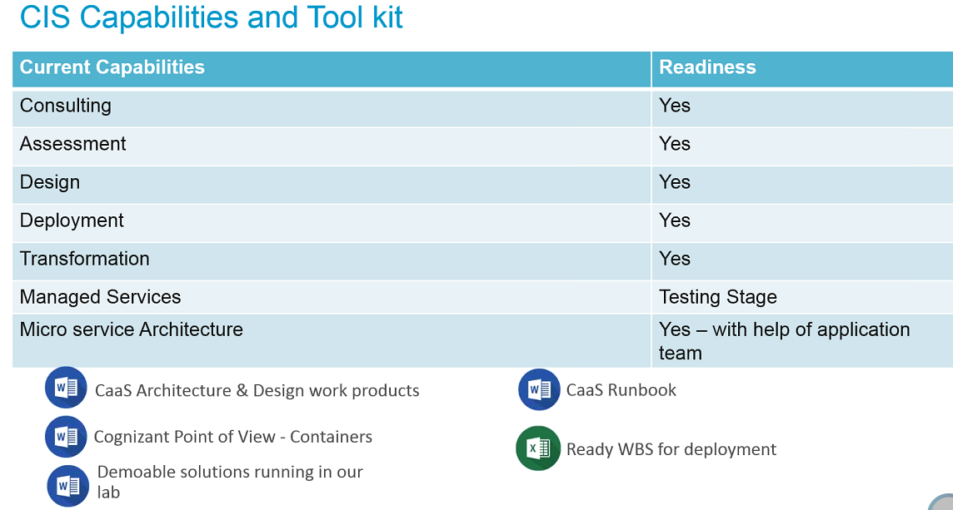

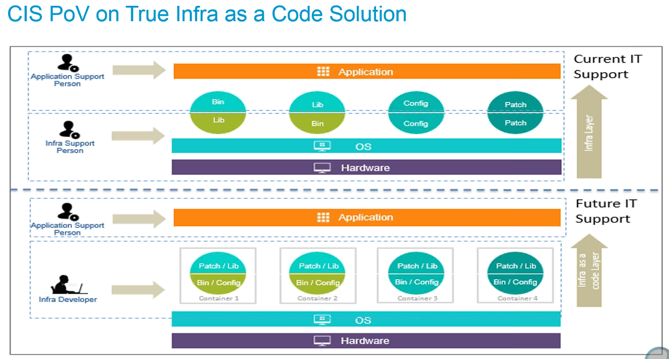

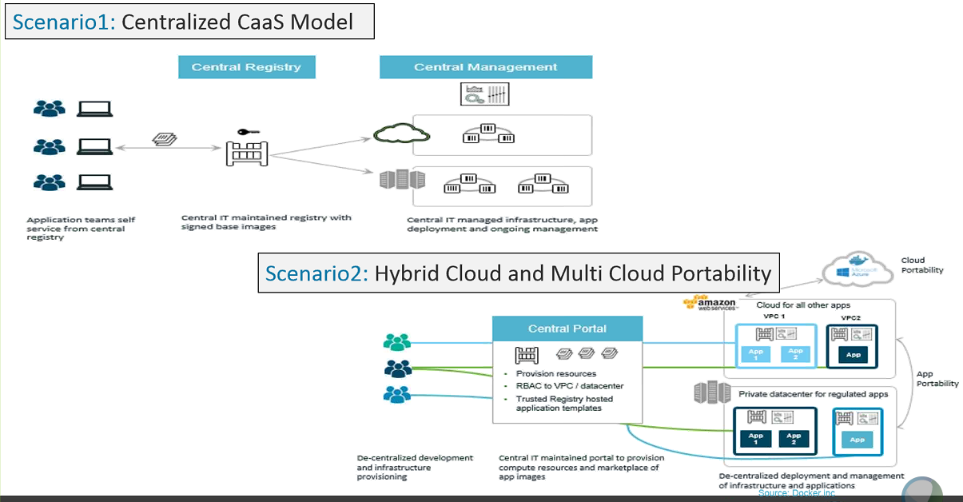

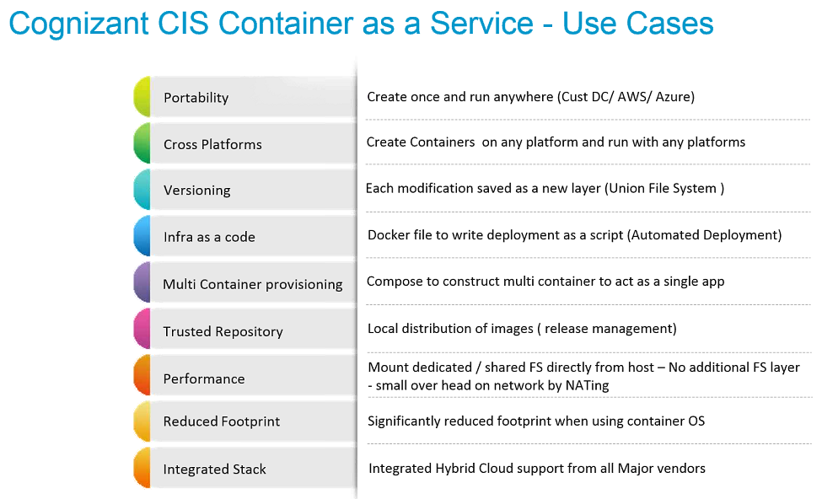

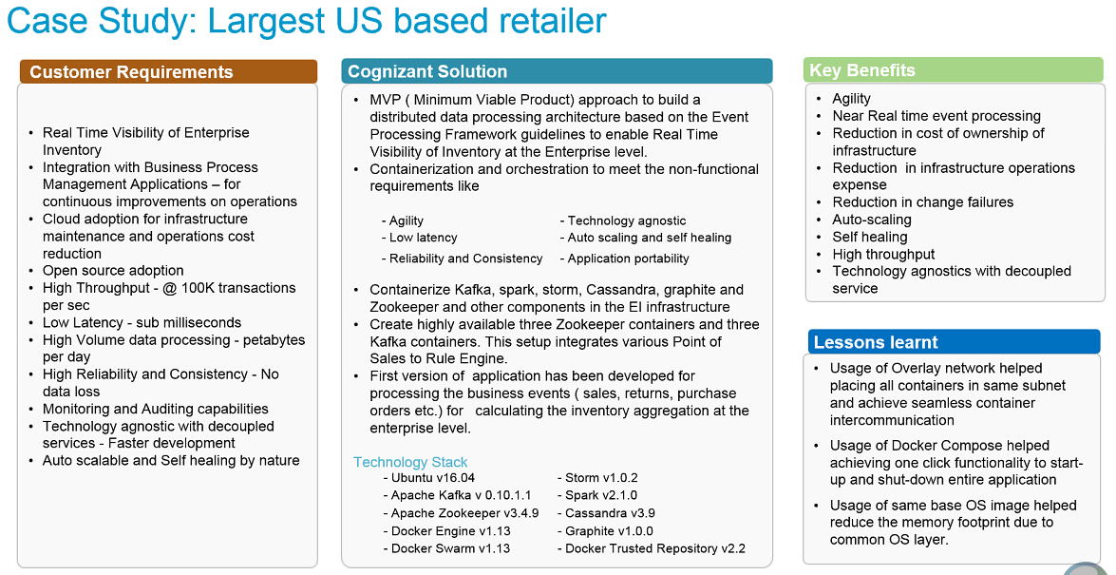

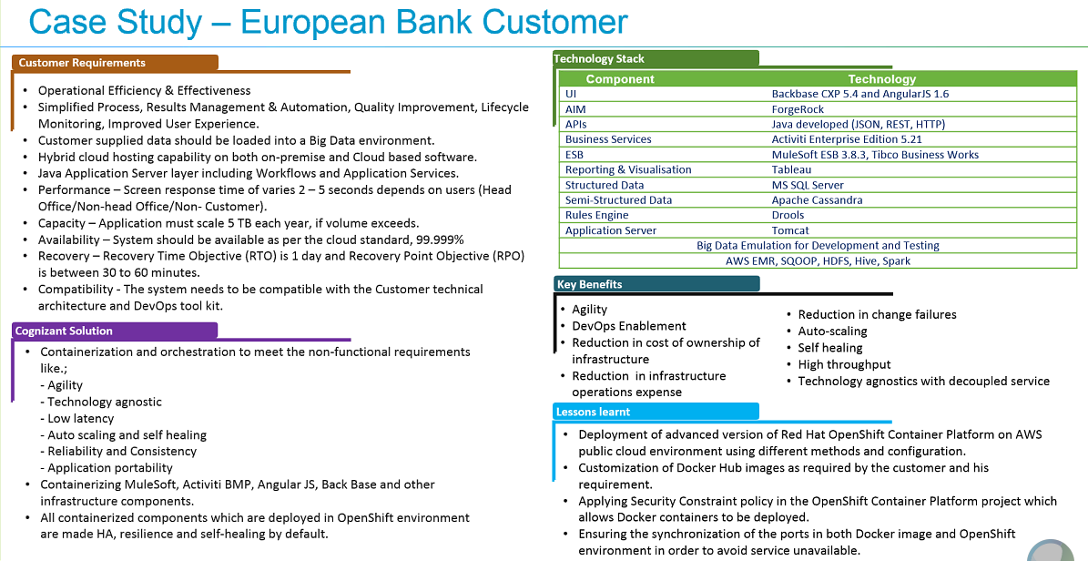

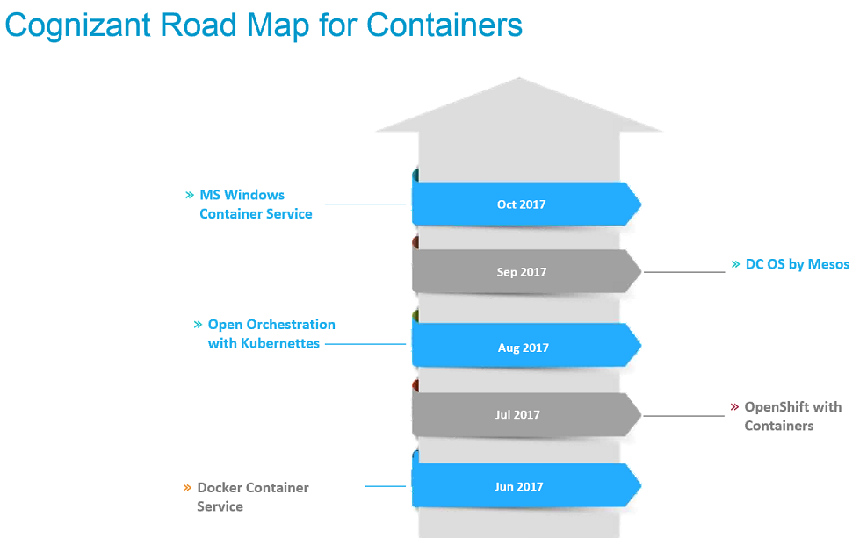

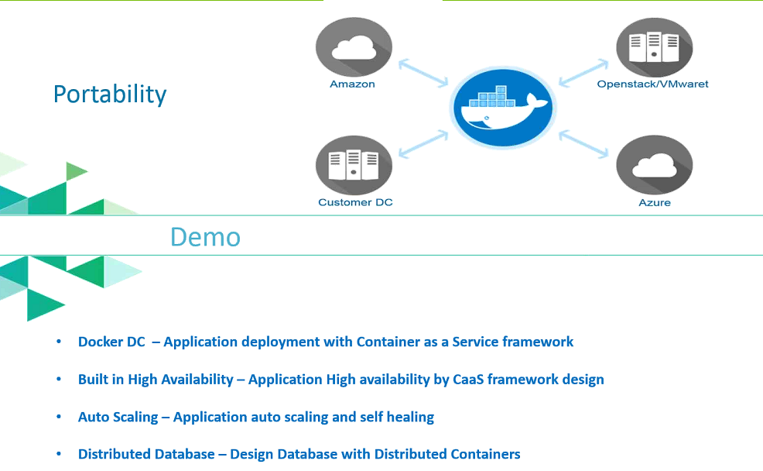

from RajeshKumar Chendru to everyone:

Containers and serverless (like AWS lambda) computing, how are they different

from Terence Okus to everyone:

Both Docker & AWS Lambda can be used to build microservices, but the two serve different needs. Container orchestration isn't used to build serverless(not cost effective) and Lambda can't be used exclusively to build most apps bein worked on. They're two different tools. HTH.

from Ram Krishna Ghildiyal to everyone:

And AWS Lambda functions run in response to an event; so it is mostly for event driven programming model

from Sreekanth Sreekumar to everyone:

How is container different from JVM ?

from Ram Krishna Ghildiyal to everyone:

JVM is a container to run the app in the "client machine"

from Sreekanth Sreekumar to everyone:

so,.. is docker comparable to JVM ?

from Ram Krishna Ghildiyal to everyone:

no

from Ram Krishna Ghildiyal to everyone:

Docker is for full stack applicatiaon that can take inputs from external interfaces viz network sockets and SAN device pointers

from Ataur Rahman to everyone:

if OS is shared in containers, and only one OS can be used at a time. then won't the solution prove costly having multiple containers for different OS in comparison with traditional VIRTUALIZATION

from Raja to everyone:

Every Container will have a Separate Executables hence any monolithic app can be compartmentalized for better management

from Niladri Mukherjee to everyone:

Containers share the library with the base OS, that's how they are OS dependent, so container created based on RHEL will need the same version of RHEL it was created from to run & will not run on Ubuntu or on Suse.

from Sridhar Bhaskarla to everyone:

Visualize container as a process running in the OS except that it has everything such as libraries, application within

from Niladri Mukherjee to everyone:

usually a client does not run different applications on different version of OS - the standard practice is to use same OS for administration benefit.

from pragnesh to everyone:

the same concept was introduced in solaris 10 - zones almost 10 years back.. isnt it ?

from Niladri Mukherjee to everyone:

but the agility container technology provides will off set all other aspects including the cost.

from Ashish Ratnu to everyone:

That is correct

from Niladri Mukherjee to everyone:

but it is not a solution to all scenarios or problems. It is particularly useful for small application that fits micro architecture model......

from Abhay Patil to everyone:

IBM introuduced it far ago in the concept of WAR - sys level and app level

from Niladri Mukherjee to everyone:

yes

from sswaroop to everyone:

LAMP, Lower level applications..

from rajarajan.kannan to everyone:

WPAR -Workload partitions

from Niladri Mukherjee to everyone:

it is a very old concept but it was not usable in intel/linux platform in large csale also it was very complex, but now docker just made it very simple to implement & use.

from Niladri Mukherjee to everyone:

even Windows server 2016 in colaboration with docker is providing container technology.

from Niladri Mukherjee to everyone:

the technology is still evolving & security is still a concern.

from Niladri Mukherjee to everyone:

but those issues are being addressed very aggrasively

from Samir to everyone:

Windows server 2016 and Nano server are designed to reduce the patching and reboot.

from Niladri Mukherjee to everyone:

Kubernetes provides the orchestration for containers & making it more usable in the enterprise environment with high availability & redundancy

from jairo to everyone:

Linux has had containers for a long time: LXC. And using SELINUX on LXC and DOCKERS' secures the operation and use of containers. Not sure how security is managed in Windows.

from Navneet Gupta to everyone:

how is licensing managed here, e.g: contanarize tools like DB (oracle), app servers (WAS, WLS)

from Niladri Mukherjee to everyone:

yes, absolutely correct but that was very very complex to understand & even use

from jagdish to everyone:

How the OS licensing and replication works in docker container platform?

from Niladri Mukherjee to everyone:

Docker just extended those features made it simple to implement & use in a practical scenario

from Niladri Mukherjee to everyone:

no license - the same Base OS license is used because container does not have any dedicated OS

from Niladri Mukherjee to everyone:

if you are running 10 Containers on one base OS - it is just one OS license that you need to use all 10 Containers.

from Navneet Gupta to everyone:

thx

from Niladri Mukherjee to everyone:

yw

from Niladri Mukherjee to everyone:

containers only share libraries with the base OS

from Niladri Mukherjee to everyone:

basically it is application virtualization

from manoj sinha to everyone:

What type of HA and DR setup it has? And is there any stoarge replication feature between prod and DR like VMWare?

from Niladri Mukherjee to everyone:

vs Hardware virtualization provided by Hypervisors like ESXi, KVM

from jairo to everyone:

some processes and storage space are being shared as well.

from RajeshKumar Chendru to everyone:

Containers and serverless (like AWS lambda) computing, how are they different

from Terence Okus to everyone:

Both Docker & AWS Lambda can be used to build microservices, but the two serve different needs. Container orchestration isn't used to build serverless(not cost effective) and Lambda can't be used exclusively to build most apps bein worked on. They're two different tools. HTH.

from Ram Krishna Ghildiyal to everyone:

And AWS Lambda functions run in response to an event; so it is mostly for event driven programming model

from Sreekanth Sreekumar to everyone:

How is container different from JVM ?

from Ram Krishna Ghildiyal to everyone:

JVM is a container to run the app in the "client machine"

from Sreekanth Sreekumar to everyone:

so,.. is docker comparable to JVM ?

from Ram Krishna Ghildiyal to everyone:

no

from Ram Krishna Ghildiyal to everyone:

Docker is for full stack applicatiaon that can take inputs from external interfaces viz network sockets and SAN device pointers

from Ataur Rahman to everyone:

if OS is shared in containers, and only one OS can be used at a time. then won't the solution prove costly having multiple containers for different OS in comparison with traditional VIRTUALIZATION

from Raja to everyone:

Every Container will have a Separate Executables hence any monolithic app can be compartmentalized for better management

from Niladri Mukherjee to everyone:

Containers share the library with the base OS, that's how they are OS dependent, so container created based on RHEL will need the same version of RHEL it was created from to run & will not run on Ubuntu or on Suse.

from Sridhar Bhaskarla to everyone:

Visualize container as a process running in the OS except that it has everything such as libraries, application within

from Niladri Mukherjee to everyone:

usually a client does not run different applications on different version of OS - the standard practice is to use same OS for administration benefit.

from pragnesh to everyone:

the same concept was introduced in solaris 10 - zones almost 10 years back.. isnt it ?

from Niladri Mukherjee to everyone:

but the agility container technology provides will off set all other aspects including the cost.

from Ashish Ratnu to everyone:

That is correct

from Niladri Mukherjee to everyone:

but it is not a solution to all scenarios or problems. It is particularly useful for small application that fits micro architecture model......

from Abhay Patil to everyone:

IBM introuduced it far ago in the concept of WAR - sys level and app level

from Niladri Mukherjee to everyone:

yes

from sswaroop to everyone:

LAMP, Lower level applications..

from rajarajan.kannan to everyone:

WPAR -Workload partitions

from Niladri Mukherjee to everyone:

it is a very old concept but it was not usable in intel/linux platform in large csale also it was very complex, but now docker just made it very simple to implement & use.

from Niladri Mukherjee to everyone:

even Windows server 2016 in colaboration with docker is providing container technology.

from Niladri Mukherjee to everyone:

the technology is still evolving & security is still a concern.

from Niladri Mukherjee to everyone:

but those issues are being addressed very aggrasively

from Samir to everyone:

Windows server 2016 and Nano server are designed to reduce the patching and reboot.

from Niladri Mukherjee to everyone:

Kubernetes provides the orchestration for containers & making it more usable in the enterprise environment with high availability & redundancy

from jairo to everyone:

Linux has had containers for a long time: LXC. And using SELINUX on LXC and DOCKERS' secures the operation and use of containers. Not sure how security is managed in Windows.

from Navneet Gupta to everyone:

how is licensing managed here, e.g: contanarize tools like DB (oracle), app servers (WAS, WLS)

from Niladri Mukherjee to everyone:

yes, absolutely correct but that was very very complex to understand & even use

from jagdish to everyone:

How the OS licensing and replication works in docker container platform?

from Niladri Mukherjee to everyone:

Docker just extended those features made it simple to implement & use in a practical scenario

from Niladri Mukherjee to everyone:

no license - the same Base OS license is used because container does not have any dedicated OS

from Niladri Mukherjee to everyone:

if you are running 10 Containers on one base OS - it is just one OS license that you need to use all 10 Containers.

from Navneet Gupta to everyone:

thx

from Niladri Mukherjee to everyone:

yw

from Niladri Mukherjee to everyone:

containers only share libraries with the base OS

from Niladri Mukherjee to everyone:

basically it is application virtualization

from manoj sinha to everyone:

What type of HA and DR setup it has? And is there any stoarge replication feature between prod and DR like VMWare?

from Niladri Mukherjee to everyone:

vs Hardware virtualization provided by Hypervisors like ESXi, KVM

from jairo to everyone:

some processes and storage space are being shared as well.

from Niladri Mukherjee to everyone:

you'll need to develop your architecture & implement using Kubernetes

from jagdish to everyone:

How the sizing works over here? I mean on 1 server (32 core, 2TB) memory, how many containers I can fit?

from Karthik Rajasekaran to everyone:

how do we manage the presistance data ?

from Niladri Mukherjee to everyone:

it should be depending on the size of the application you'll be hosting using your containers.... Remember containers are very good candidate for hosting small applications & not good for Heavy Duty applications

from Niladri Mukherjee to everyone:

it has the ability to use persistant storage volume

from Abhay Patil to everyone:

True

from Madhava to everyone:

Is there any restriction on what appliactions can be installed on containers?

from Niladri Mukherjee to everyone:

by its nature every container is ephemeral in nature meaning it will loose all data upon restart - so for real life application we must use persistant storage

from Arun Kumar to everyone:

Licensing is a key aspect. Basically its the software vendor who will comeup with the charging strategy for using their products. Monitoring is one of the important aspect in telling the consumption and based on that vendors can charge to the customers

from Madhava to everyone:

Is it only Webservers, Application Servers...

from Madhava to everyone:

??

from Niladri Mukherjee to everyone:

no

from Niladri Mukherjee to everyone:

not just web application but it is a very good candidate for we application

from Niladri Mukherjee to everyone:

you can host any applications

from Madhava to everyone:

For e.g. Database can be installed on docker?

from Niladri Mukherjee to everyone:

Docker swarm is like Kubernetes but in industry Kubernets is preffered

from Arun Kumar to everyone:

Yes, DB can be installed on containers

from jagdish to everyone:

Is SAP, Hadoop, Oracle DB as well supports by Container?

from Niladri Mukherjee to everyone:

yes, it can be but again the feasibility has to be determied whether it makes sense to use a Oracle DB on a container

from Madhava to everyone:

Even after installing DB on docker..still it will have image size 40-50MB?

from Niladri Mukherjee to everyone:

even en entire openstack environment can be run on container...... so it is capable

from Abhay Patil to everyone:

40-50 Mb size of docker not application

from Arun Kumar to everyone:

Madhava, there is a base OS image called Alpine which is 5MB in size

from Arun Kumar to everyone:

you can install anything on top of Alpine image. So if DB size is 50MB then image size will be 55MB

from Madhava to everyone:

K..my question is..when docker containers moved from one cloud to another....that will take app with it right?

from Niladri Mukherjee to everyone:

yes, it should

from Arun Kumar to everyone:

Yes. its like an appliance so everything move together

from Niladri Mukherjee to everyone:

that's the idea of being shipable

from Madhava to everyone:

So how come it will be just 40MB after DB in it?

from Niladri Mukherjee to everyone:

the data vlume is seprate

from sswaroop to everyone:

How about DR setup

from Niladri Mukherjee to everyone:

container does not contain data within it - it is ephemeral

from Arun Kumar to everyone:

just the binary plus whatever space Data takes

from Arun Kumar to everyone:

Niladri, container can contain data, we loose data only when we remove the container

from jagdish to everyone:

How containers migrate from 1 DC to another DC environmrent? Is there any tool for the same?

from Arun Kumar to everyone:

Jagadish, Docker Hub or Docker Trusted registry is used for it

from Aman Chowdhary to everyone:

DBs usually have high upstream/ downstream dependencies / interact with multiple apps. In such a scenario is it recommended to containerize DB? Also, are there any restrictions on communication among containers?

from Madhava to everyone:

Our client also exploring docker containers..i see its an oppertunity for Cognizant to pitch in...

from Arun Kumar to everyone:

We have achieved Data persistence by using 3rd party tool to persist data. we'll demo that in this session if time permits

from Madhava to everyone:

whom to contact for that from Cognizant?

from Niladri Mukherjee to everyone:

@Arun - ok, but that the base container we have build, my understanding is if we write something in the container during operation - gets lost if we bounce the container, that's why we need to have persistant storage volme attached to the container for retaining the data.

from jagdish to everyone:

Can container supports 3rd. party tool install like platespin, zenoss etc?

from Niladri Mukherjee to everyone:

@Arun - That's a great news!!

from Arun Kumar to everyone:

Bouncing a container does not remove data. Deleting a container only removed the data

from Niladri Mukherjee to everyone:

ok ok

from Karthik Rajasekaran to everyone:

Would someone share the deck .. i think it has more info in it.. which needs more time to go through..

from jagdish to everyone:

Is Exchange, sharepoint as well get install on container pplatform?

from Arun Kumar to everyone:

Jagadish, we can install many applications and even start them using a single script. but thts a bad design, not recommended

from Niladri Mukherjee to everyone:

Windows containers are very newly launced by Microsoft - not sure how mature & stable Server 2016 container platfor is now.

from Arun Kumar to everyone:

Zenoss and such monitoring tools are not much relevant because container monitoring is a completely different ball game and new tools are evolving for monitoring in resonable way

from Niladri Mukherjee to everyone:

The technology is more mature on Linux platform as of now

from jagdish to everyone:

Many thanks Arun, appreciate for your quick responses :)

from GOWRISH S to everyone:

howz kafka and docker are different

from Arun Kumar to everyone:

just like kafka and a physical server

from jairo to everyone:

Jagadish, think about business applications, not infra applications. Reduce the TCO of SDLC and operations of the infra needed for an application. Embrace DevOps to reduce TCO, reduce risk via standardization, increase automation. Applications get simplified, and automatically become elastic. without worrying about the underlying infrastructure any more.

from jagdish to everyone:

Point noted @jairao, thx

from manoj sinha to everyone:

Do we any work space that we can login to expore docker container?

from Sreekanth Sreekumar to everyone:

can you deploy a docker created for Linux on a Windows OS ?

from Raja to everyone:

Folks if you are managing client project and see a heavy dominance of VM it is time to move them to a Container based model as part of Cloud Transformation. Proactive pitch we need to make...This is poised to rule for next 5 years or so unless something new comes and disrupt

from Niladri Mukherjee to everyone:

But the point to remember is containers is not a 100% replacement for VMs but I 100% agree to the note that it is going to rule the market for next 5+ years

from Baranidharan.S to everyone:

do we have auto scaling options as well ?

from Niladri Mukherjee to everyone:

yes, it can be implemented using some orchestration tool

from Niladri Mukherjee to everyone:

btw i mean adding more container but not increasing the size of the container itself

from Sreekanth Sreekumar to everyone:

how to keep the CMDB updated in such scenarios ? Also how will to develop the application dependency mapping ?

from jagdish to everyone:

nice feature :)

from jairo to everyone:

in my mind, the main questions clients will have are: how are CMDB updates and how is container proliferations being managed ?.

from pragnesh to everyone:

when you scal app. to multiple container - those container will be scaled across different physical host or same physical host in backend ?

from Ram Krishna Ghildiyal to everyone:

April 14th?

from SANDEEP ASHTEKAR to everyone:

i am from Infra side , in plans to do lot of technology refresh. how much denifit it will give me there ? any case study on Data Center and Branch Office steup ?

from Brendan Holmes to everyone:

Pls summarise why I should use this rather than Kubernetes.